Unit 1, Lesson 2: Cool-down

2.4: Comparing Polygons $ABCD$ and $PQRS$
Polygon $PQRS$ is a scaled copy of polygon $ABCD$.
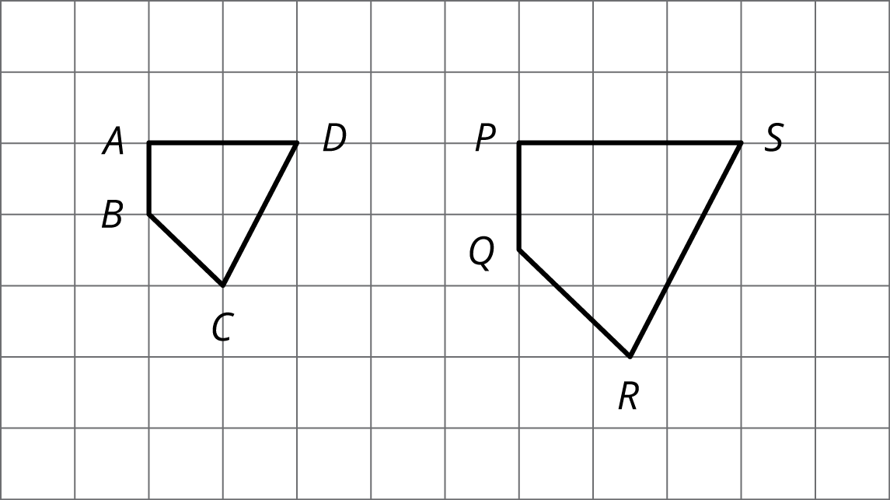
- Name the angle in the scaled copy that corresponds to angle $ABC$.
- Name the segment in the scaled copy that corresponds to segment $AD$.
- What is the scale factor from polygon $ABCD$ to polygon $PQRS$?

